SESSION BEGIN: 6:00pm (Board) 7:05pm (General)
SESSION ADJOURNED: 8:32pm
ATTENDEES: MINH MEDEIROS, MELISSA WILLIAMS, NICOLE SAVITSKI (phone), DARCY KENNEDY, KAYTEE MCLEAN, JACKIE ARENA, BETHANY DUBRYN
AGENDA
BYLAWS REVIEW/UPDATE
OLD JOB DESCRIPTION: Board to Review and Update
- PRESIDENT: Assumes full responsibility for the operation of the organization, responsible for registration, banquet, and uniforms
- VP: Shall act in the absence of the President, serve as Volunteer Coordinator, spearhead SLYC Fundraising activities, scholarship chairperson, SLYC Representative to OCYCA
- Secretary: Keep the minutes of all the meetings, works with President on uniform fittings and ordering, confirms all field and gym space, maintains current membership list, coordinates tumbling clinics
- Treasurer: Custodia of all funds, keeps detailed books, prepares budgets and monthly reports
- Coach/Safety Coordinator: Acts as the primary SLYC representative to the OCYCA Board and attends all OCYCA meetings, coordinates competitions (Logistics, registration, waivers, transportation and parent communication)
- Updated bylaws through executive board duties
- Changed around job descriptions for board
- Adding fundraising head (fundraising committee & scholarship committee)
- Concussion certification for coaches, board, and team moms
- Once these are fully read through and finished, the board will post the updated version
- 2021 SEASON BANQUET – SATURDAY, MARCH 5th 9am-1pm
  - LOCATION: Fireside Grille, Middleboro, MA
  - COST: $35/pp (up to 2 guests), Cheerleader is Free, 7% Tax Exemption
  - DJ: Tony Amoroso $250
  - PHOTOBOOTH – $300 Bella & Co Photobooth
  - LAURIE/COACH APPRECIATION – Garden $50 Gift Card (Val to get)
    - COACHES: Sarah, Teri & Michelle : Polished Nail Gift Certificates – Kaytee to purchase and reimbursed
    - Jr. Coaches (8): Addison, Emma, Kayleigh, Cloe, Abby, Kate, Meadow, Juliana – Candy Bouquets $20
    - TEAM MOMS (3): Jackie, Marissa, Cassie - Polished Nail Gift Certificates – Kaytee to purchase and reimbursed
  - TABLE FOR REGISTRATION FOR UPCOMING YEAR – Minh to get QR code and frame for Registration table
- 2022 SEASON
  - KYSO INFORMATION MEETING SATURDAY, 4/2, 9-1PM, TEACH A CHEER
    - VOLUNTEERS: Need to assign times
      - COACH SARAH CROCKETT
      - ALISA SPECKMANN
      - MARISSA SWEENEY
      - JACKIE ARENA
      - COACH MICHELLE HURLEY
      - Can we get High Schoolers to volunteer – Jess McStowe/Nicole to follow up
    - FLIERS FOR SCHOOLS (ONLINE & PRINT) – Minh to create flier. Post on all Town and Class pages. Must be transparent and include all costs upfront.
      - Cheer Competitions (3), Choreography Routine (1 full day of camp), 2 (2-hr) Practices Each week (3 practices/week in August), 1 hr Tumbling, Season Tees, Bows (2)
      - Kaytee to call for K-7 #s and post on Class pages. Darcy to reach out to Plympton
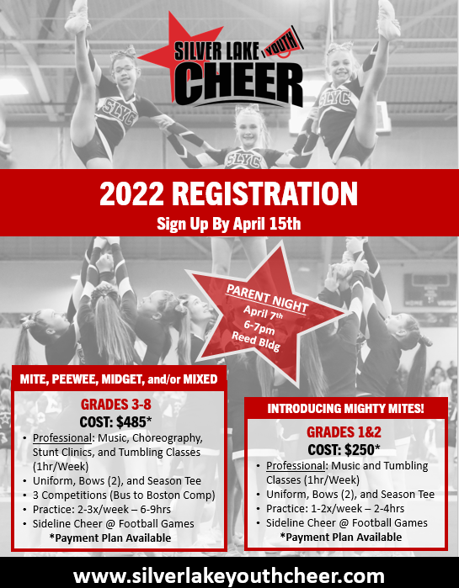
    - SELL SWAG – Bows $10, giveaway 2021 Tees
    - SCRATCH TICKET BOARD – Nicole to coordinate $200
  - REGISTRATION OPEN & CLOSE DATE – $50 NON-REFUNDABLE Pre-Registration at Banquet and Registration Open 3/14 – 4/15. Minh to create QR code to direct link to registration page.
  - UNIFORM TRY ON DATE – Saturday, May 21 early am
  - MITEY MITES TEAM – Darcy to lead the team, 12 kids max, $250 Registration fee includes cost of uniform
- TREASURER REPORT
  - What do we want to do with all this money sitting in the bank? Uniforms, Shed, Mats…etc
    - Storage unit instead of shed so animals don’t eat uniforms?
  - Looking to purchase new uniforms if we can get them in time for the season.
    - Rebel & Varsity Reps: 45-60 Days for production after they do prototype (4 weeks). They will send Kaytee the look books.
    - 45-60 Days
    - Approve designs by end of March
- PARENT/COACH SURVEYS
  - Communication (FB, Email, Sports App) – Part of survey to determine which is best method. Team Moms will be primary source of updates to each team. They will work closely with the Coaches. Monthly Newsletter/Board Recaps sent out by President for topline important information.
- LOGO/BRANDING
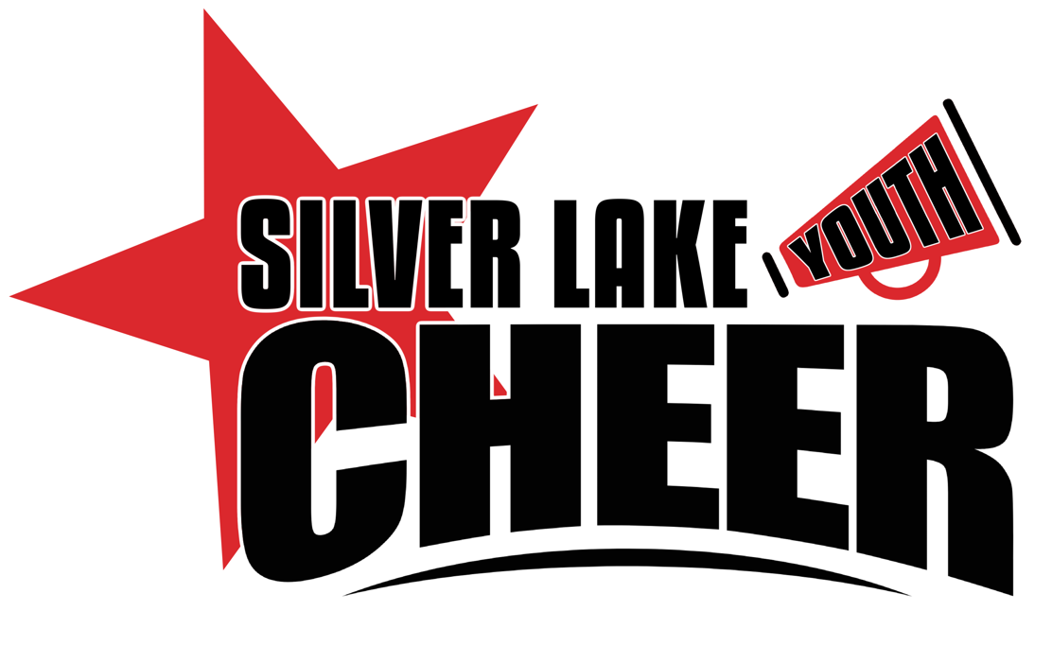
COMMUNICATION
- INTRODUCTIONS
  - OCYCA – Letter written to introduce new board, Val to provide address
  - First Practice in August will be a athlete/parents/coach/board meet & greet. Set all the rules/guidelines/expectations for the season.
  - Parent/Coach Survey
    - Communication via App
    - FB will be kept open for General updates and photos
- BOARD MEETING DATES – 1st Thursday of the Month
- NEXT MEETING WILL BE Thursday, April 7th. Parent Meeting 6-7PM, Board Meeting 7-8pm REED, ALL ARE WELCOME
PRESIDENT | MINH MEDEIROS | SLYCPRESIDENT@GMAIL.COM | 508.649.3599
VICE PRESIDENT | MELISSA WILLIAMS | SLYCVP@GMAIL.COM | 508.718.8646
TREASURER | DARCY KENNEDY | SLYCTREASURER@GMAIL.COM | 781.760.4046
SECRETARY | KAYTEE MCLEAN | SLYCHEERSECRETARY@GMAIL.COM | 774.269.1629
COACH COORDINATOR | NICOLE SAVITSKI | SLYCCOACHCOORDINATOR@GMAIL.COM | 781.706.7864
OCYCA REP | VAL WARWICK | GRAMMYVAL01862@COMCAST.NET | 617.462.4307
FUNDRAISING COORDINATOR | MELANIE LADSEN | SLYCFUNDRAISING@GMAIL.COM | 781.635.9126
SLYC KYSO REP | ALISA SPECKMANN | SLYC.KYSO@GMAIL.COM | 617.755.9196

